Bulk Loading of Lookups in Oracle Apps

When you have some lookups you can insert it into oracle apps by going to lookups and insert ahead. But when you have data in a large quantity it is a duplication to type and insert. We have some fnd_lookup_values_pkg, fnd_lookup_types_pkg API’s to rescue

So now lets go Step by Step to insert

Step - 1 : To identify the UI(oracle forms) from where user can be able to visualise
The path for navigation is
Application Developer -> Application - > Lookups -> Common and you will get a page as shown below

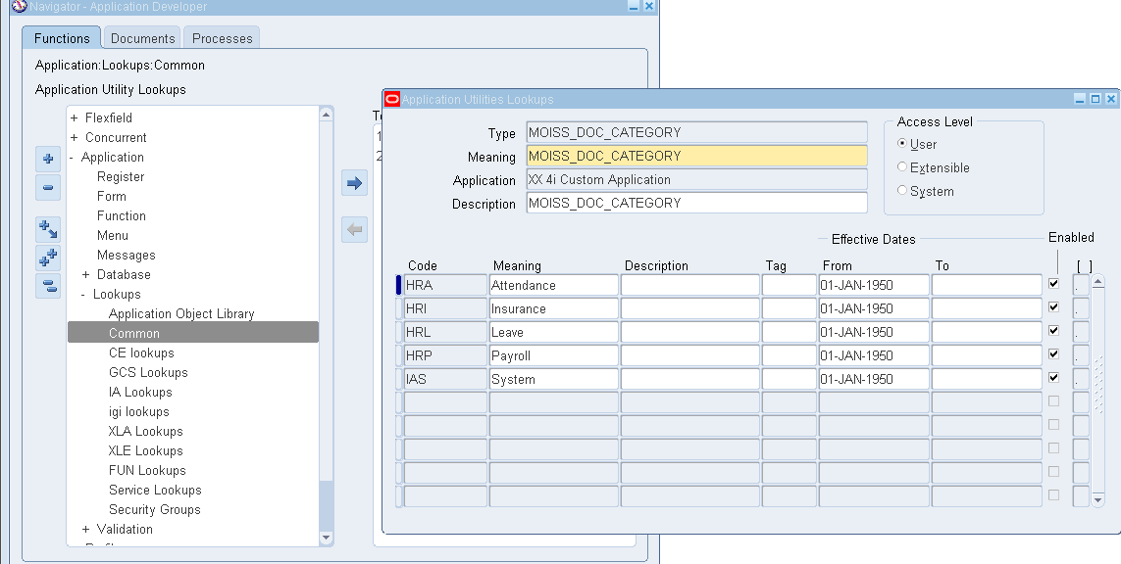

Now Just go to insert mode by pressing F11 and put % symbol to Query and press Ctrl+F11 to Query.

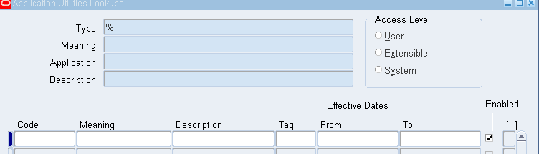

Now you will have records populated. Just click a record and go to Help -> Record History
You will get the table/view name from where the data is populated.
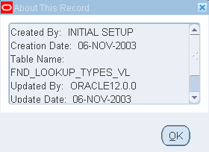
If suppose you are not able to view the record history then try this
Help -> Diagnostics -> Examine

Then you will get the below screen and set the LOV’s as shown

Block : System
Field : Last_query

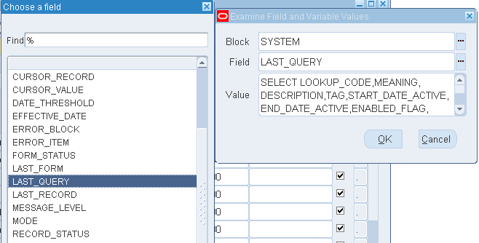

And in Value you can get the SQL query. With this we can start our hard way

Step - 2

Now we have to dig down the Query View Scripts from where the data comes.

SELECT text
FROM all_views
WHERE view_name = '%FND_LOOKUP_TYPES_VL%';

By the above query we can get the scripts for the view.

Now on analyzing we get data from fnd_lookup_types table and on analysing the values we get the data from fnd_lookup_values table.

Step - 3

When the requirement is to insert your data into oracle seeded table you have two options recommended. One is by Interface and another by API.
Here we are going to see the values to be inserted by API for a particular table.
API -> fnd_lookup_values_pkg, fnd_lookup_types_pkg
Table -> fnd_lookup_values, fnd_lookup_types
To insert into fnd_lookup_values, fnd_lookup_types table which is oracle seeded we can use the API fnd_lookup_values_pkg, fnd_lookup_types_pkg
which is a package.
Note:
To view the contents of the package
- If you use TOAD place the cursor in the pkg and press F4
- Use the Below Query to find the content
select * from user_source where name=upper(‘fnd_lookup_values_pkg’);
select * from user_source where name=upper(‘fnd_lookup_types_pkg’);

Below is the script for inserting data into table by using fnd_lookup_values _pkg

DECLARE
XROW ROWID; --You cant directly give Row Id to the x_rowid parameter,
ln_rowid1 ROWID;
cursor c is select * from xx_dept; --My Custom Query to have fetch in my custom table
cursor c1 is
select distinct lookup_type from xx_dept;
BEGIN
for i in c1 -- For loop for Inserting lookup types
loop
fnd_lookup_types_pkg.insert_row (x_rowid => XROW,
x_lookup_type => i.lookup_type, --cursor values
x_security_group_id => 0,
x_view_application_id => 3,
x_application_id => 20187,
x_customization_level => 'U',
x_meaning => i.lookup_type,
x_description => i.lookup_type,
x_creation_date => SYSDATE,
x_created_by => 1318,
x_last_update_date => SYSDATE,
x_last_updated_by => 0,
x_last_update_login => 5513095
);
DBMS_OUTPUT.put_line (XROW);
end loop; --Loop ends here
commit;
for i in c -- For loop for Inserting lookup values
loop
fnd_lookup_values_pkg.insert_row (x_rowid => ln_rowid1,
x_lookup_type => I.LOOKUP_TYPE, --Secomd cursor values
x_security_group_id => 0,
x_view_application_id => 3,
x_lookup_code => I.LOOKUP_CODE,
x_tag => NULL,
x_attribute_category => NULL,
x_attribute1 => NULL,
x_attribute2 => NULL,
x_attribute3 => NULL,
x_attribute4 => NULL,
x_enabled_flag => 'Y',
x_start_date_active => TO_DATE ('01-JAN-1950',
'DD-MON-YYYY'
),
x_end_date_active => NULL,
x_territory_code => NULL,
x_attribute5 => NULL,
x_attribute6 => NULL,
x_attribute7 => NULL,
x_attribute8 => NULL,
x_attribute9 => NULL,
x_attribute10 => NULL,
x_attribute11 => NULL,
x_attribute12 => NULL,
x_attribute13 => NULL,
x_attribute14 => NULL,
x_attribute15 => NULL,
x_meaning => I.LOOKUP_MEANING,
x_description => NULL,
x_creation_date => SYSDATE,
x_created_by => 1318,
x_last_update_date => SYSDATE,
x_last_updated_by => 1318,
x_last_update_login => 5513095
);
DBMS_OUTPUT.put_line (ln_rowid1);
end loop;
exception
when others then dbms_output.put_line('Exception Occured');
commit;
END;

